About EagleRIP on Windows Vista

1.  From EagleRIP 4.01, it supports to run on Windows Vista, and only support TIFF and Winprint driver.

2.  On Windows Vista, please do not install EagleRIP to a folder which contains a blank such as c:\Program files\, otherwise, EagleRIP cannot startup.)

3.  On Windows Vista, after you have installed EagleRIP, please make sure UAC is turned off.

a.    Go toControl panel\user accounts\ user accounts\turn user account control on or off

b.    Uncheck“Use User Account Control (UAC) to help protect your computer”.

c.    If youturn UAC on, then you cannot install options in EagleRIP.

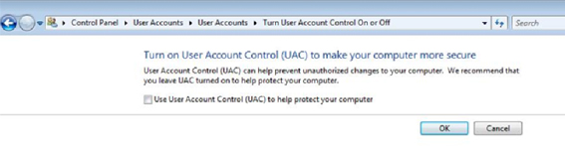

4.  For TIFF driver, please make sure the folder which saves TIFF file is not “Read Only”, otherwise EagleRIP will report an error when print a job to TIFF file (on any Windows OS).